**One App UI Flow**

1. App Splash Screen with App Logo.
2. Main Landing Screen with app Logo and Sign-In or Sign-Up options.

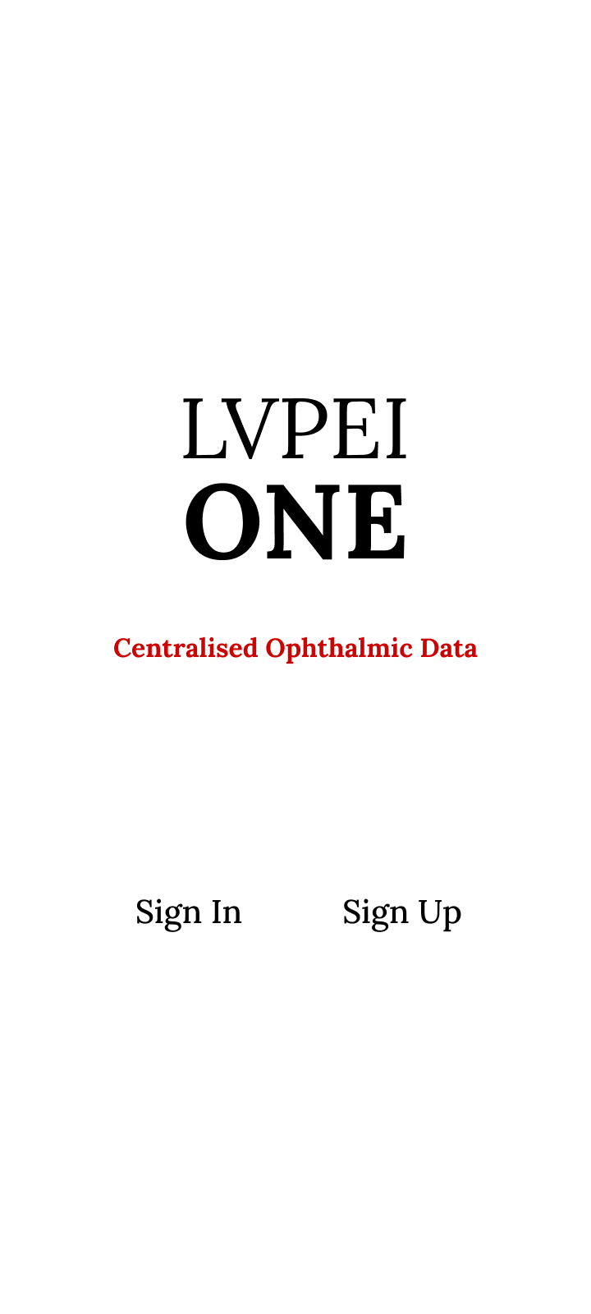

1. App registration/sign-up screens featuring text input fields for user details and validation messages.

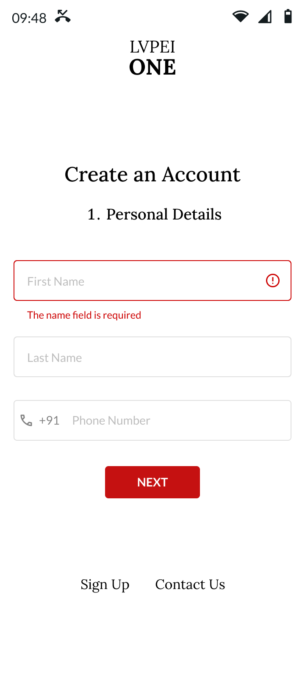 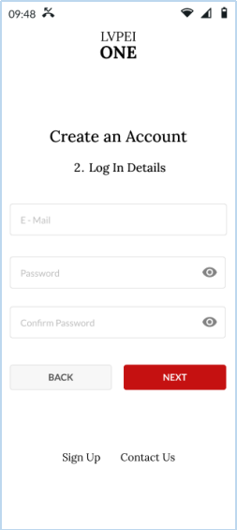

1. User Sign In screens featuring text input fields for Email ID and password with validation messages.

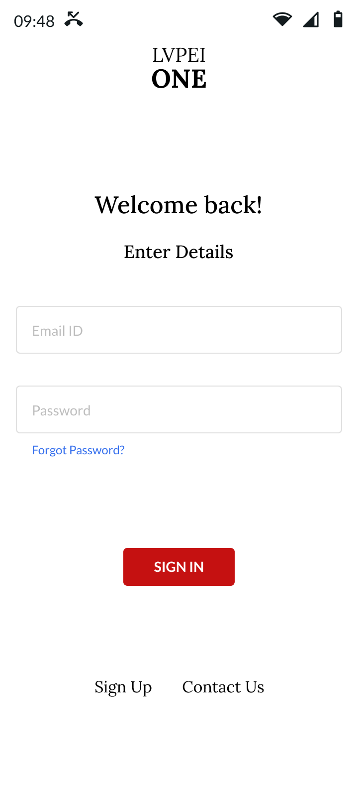 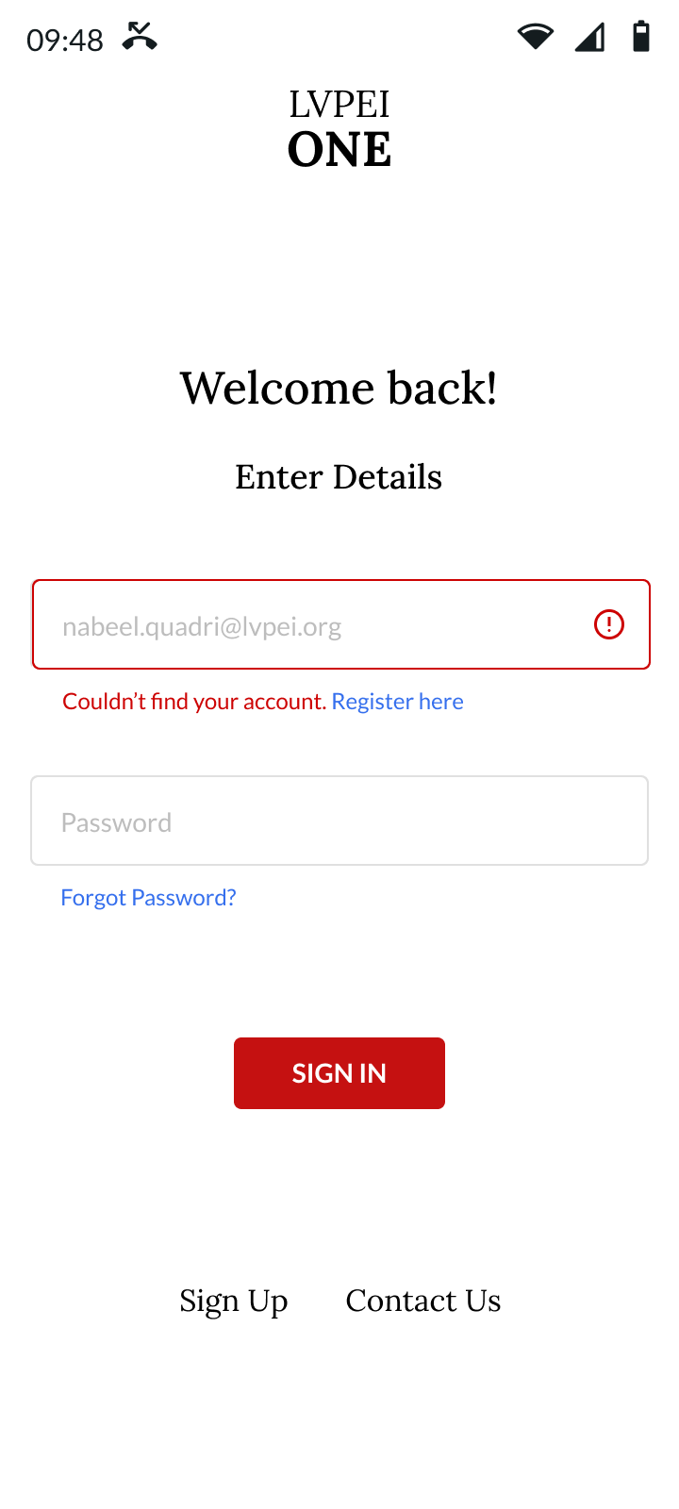

1. Forgot Password screen having text input field for Email ID with validation messages.

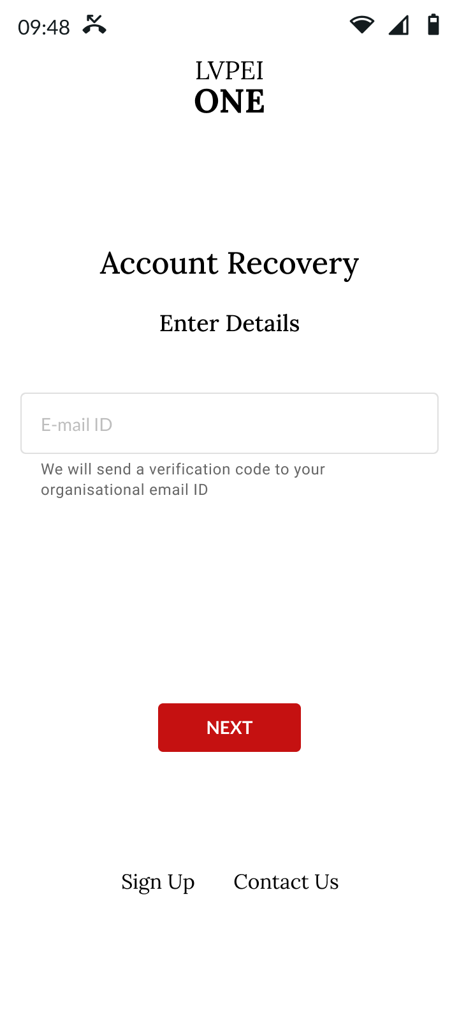

1. Main Home Screen UI with center/organization selection drop down, Doctor/Examiner user details, Different App Modules navigation button icons & Notification Icon.

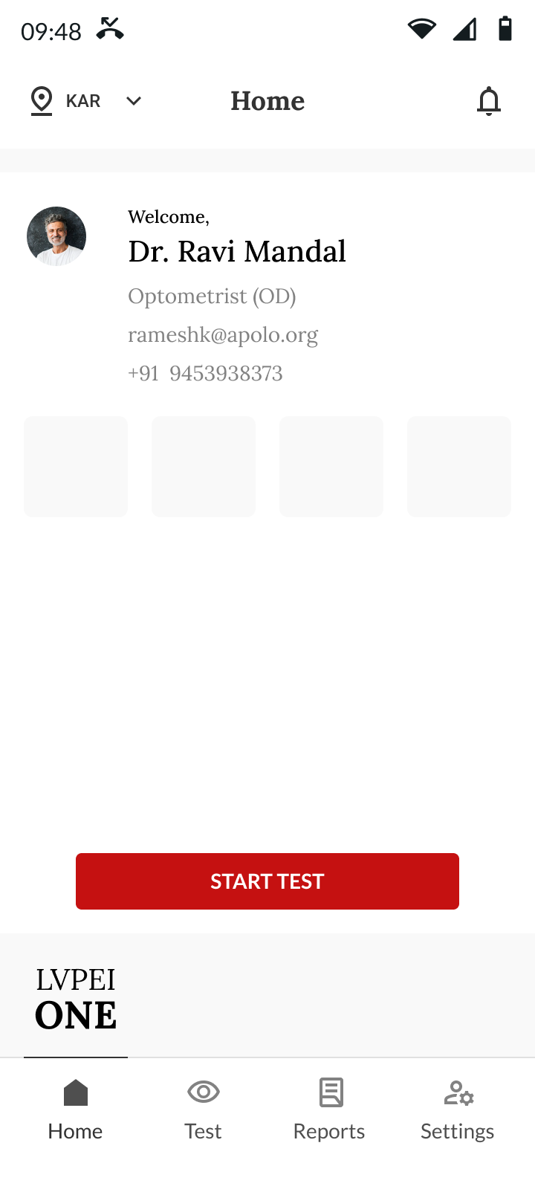 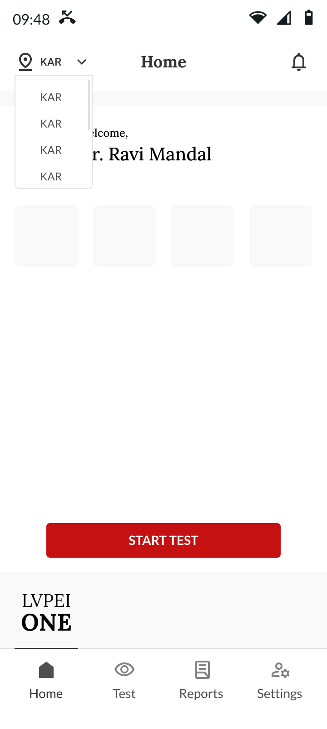

1. Test Module tab: Main screen for test setup featuring a Patient MRN text input field, Add new patient button, Test Device selection menu, and Campus selection menu. Additionally, ensure that validation UI for all fields is incorporated.

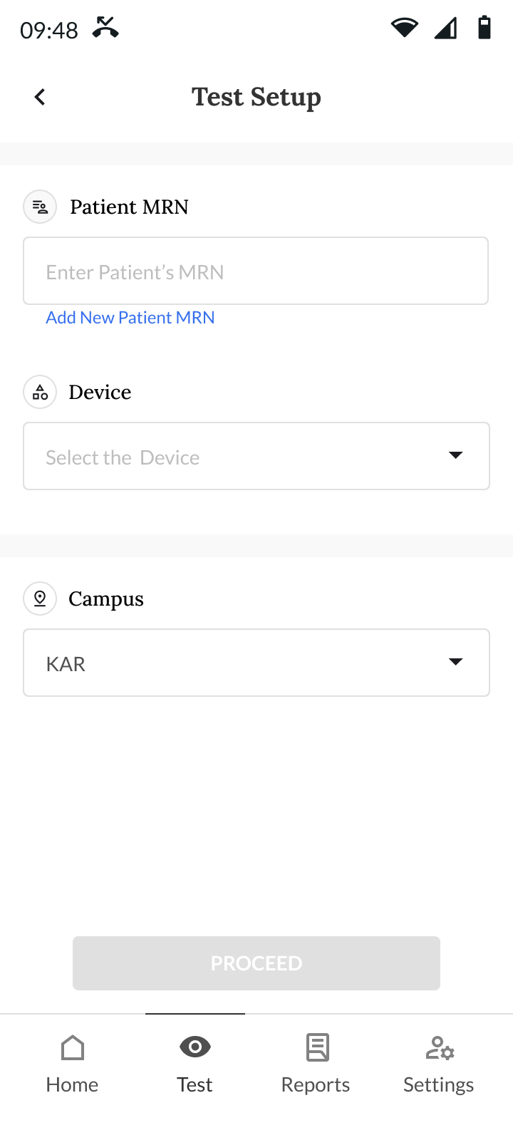

1. Patient MRN validation function UI, where each instance will display text in a different color.
2. Empty input box with add new patient button.

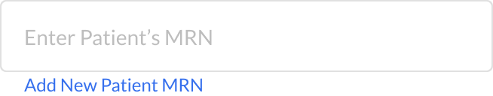

1. If MRN is valid and already exists in DB “Patient is registered” is displayed.

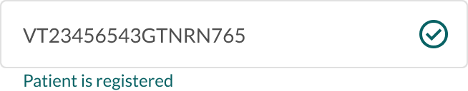

1. If MRN not valid and not exists in DB “Patient not found!” is displayed with “Register Here” button which navigates to “Add New Patient MRN” screen.

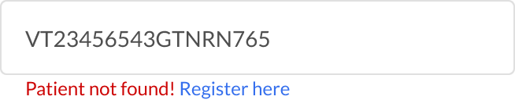

1. Add a new Patient screen with input text fields for patient name, phone number, and selection fields for gender and DOB. Additionally, ensure that validation UI for all fields is incorporated.

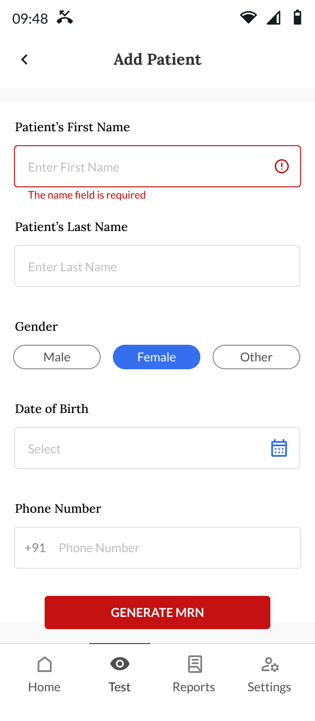

1. Test setup: Device selection list for different Eye test modules. Each device can have a color icon against their name.

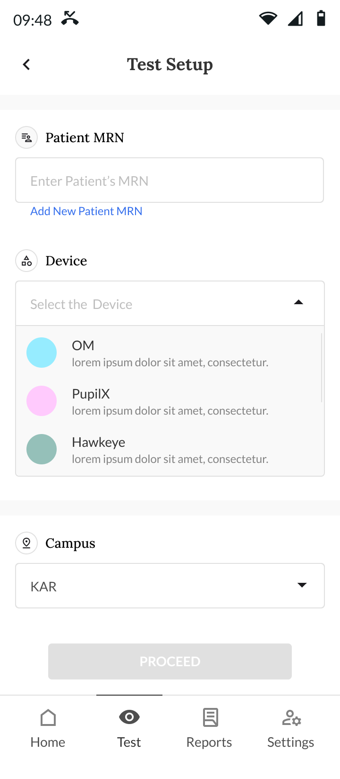

1. OM Test Setup: Selection icons for the eye to be tested (Left/Right/Both), a list for Om testing protocols, and a text input field for Device code.

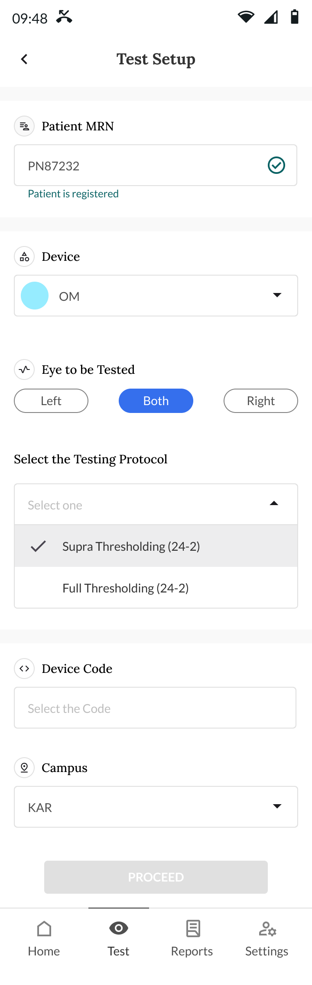

1. Validation to check whether the provided Device code is valid and exists in the database. (Common for OM & PupilX tests)

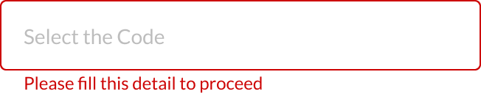

1. Device code dynamic list from DB UI. (Common for OM & PupilX tests)

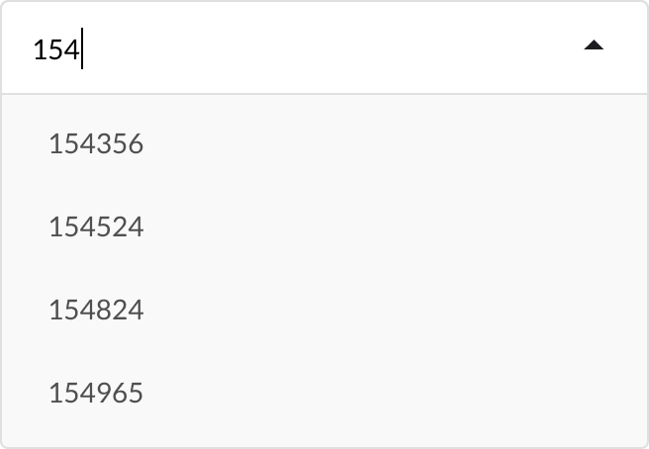

1. OM Test:
2. Pre-test start screen displaying selected patient details, chosen OM test protocol details, and instructions for headset adjustment.

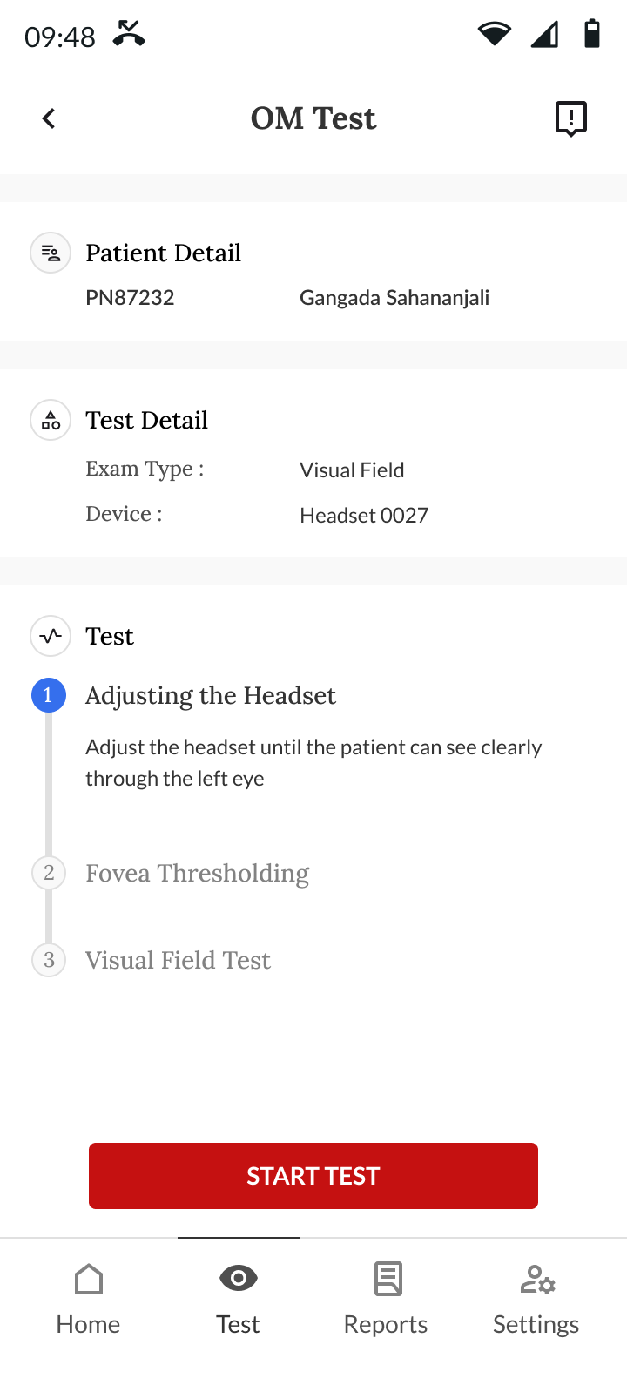

1. Screens providing instructions and validations for various stages of the OM test.

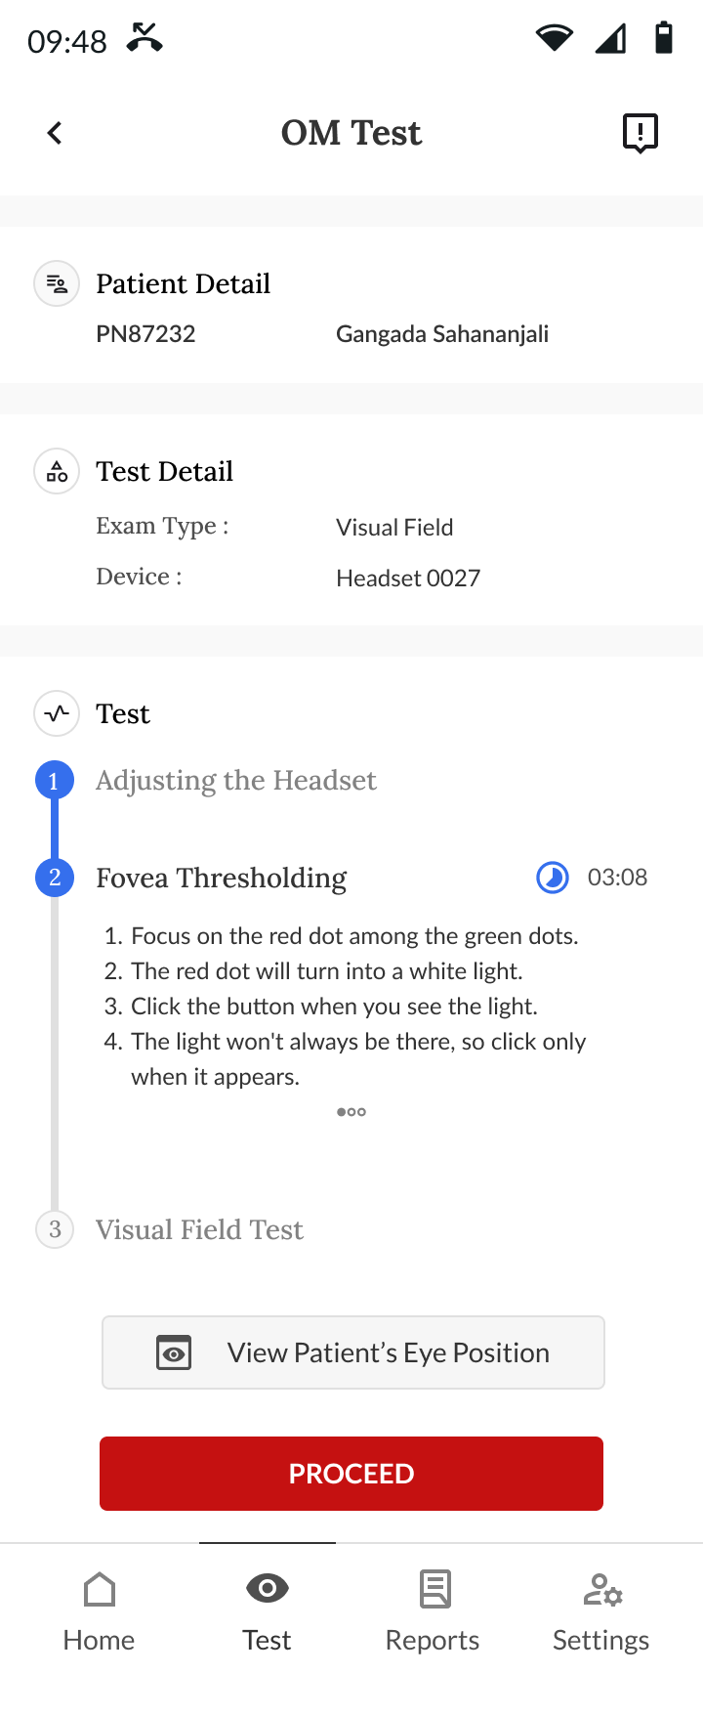 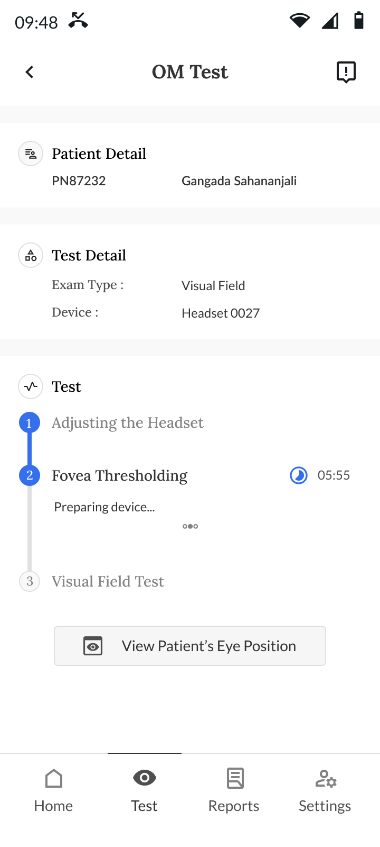 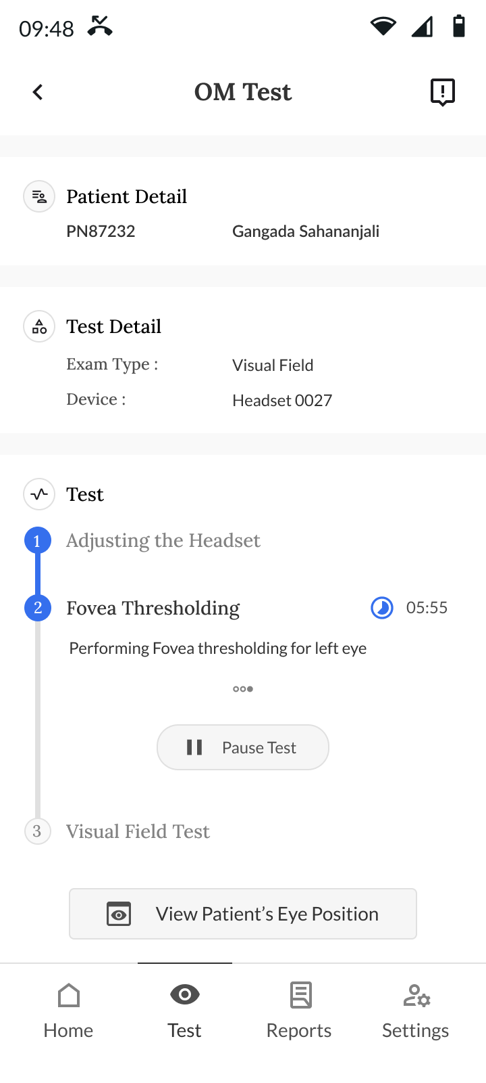

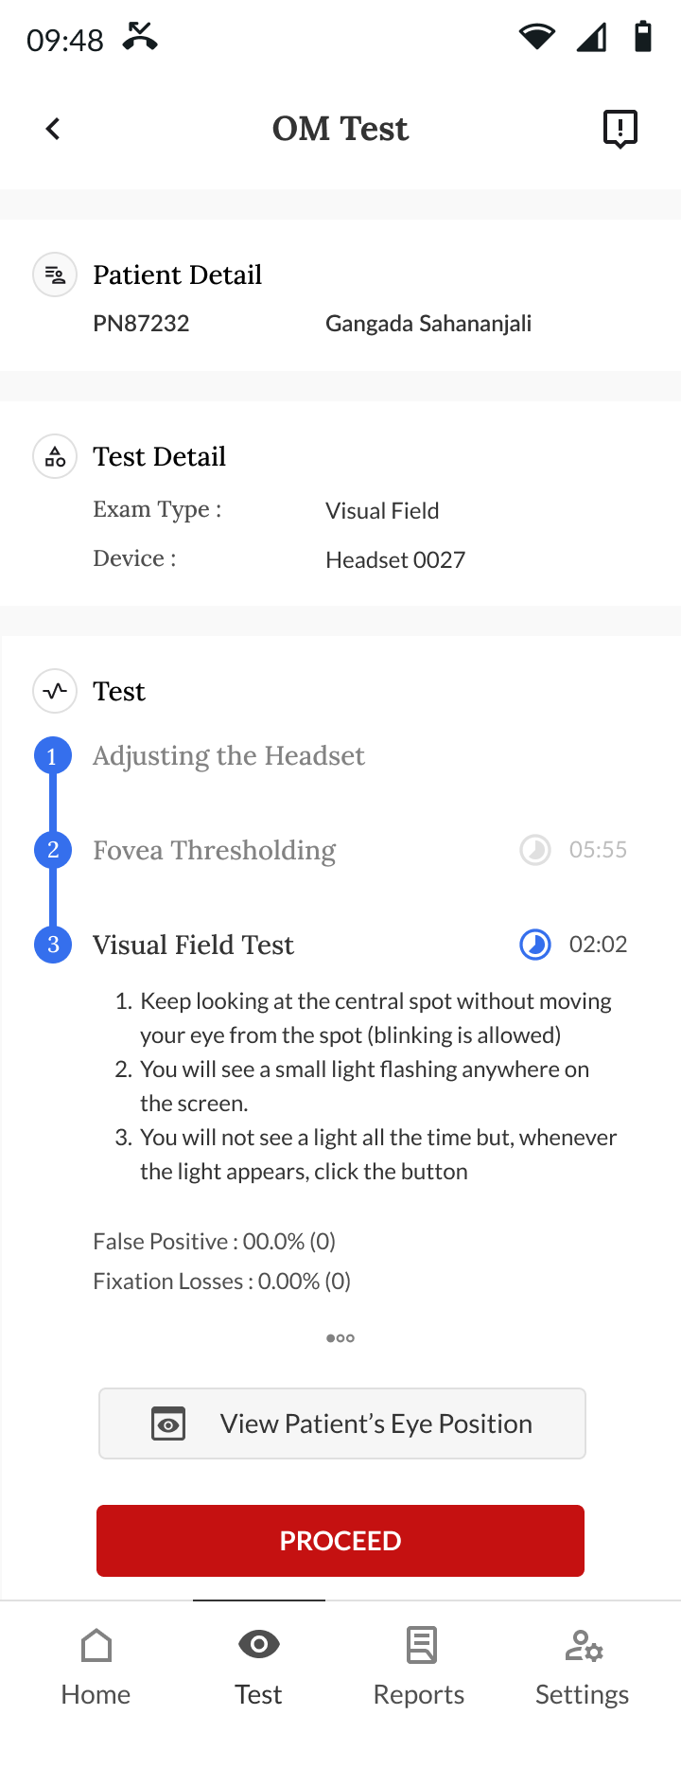 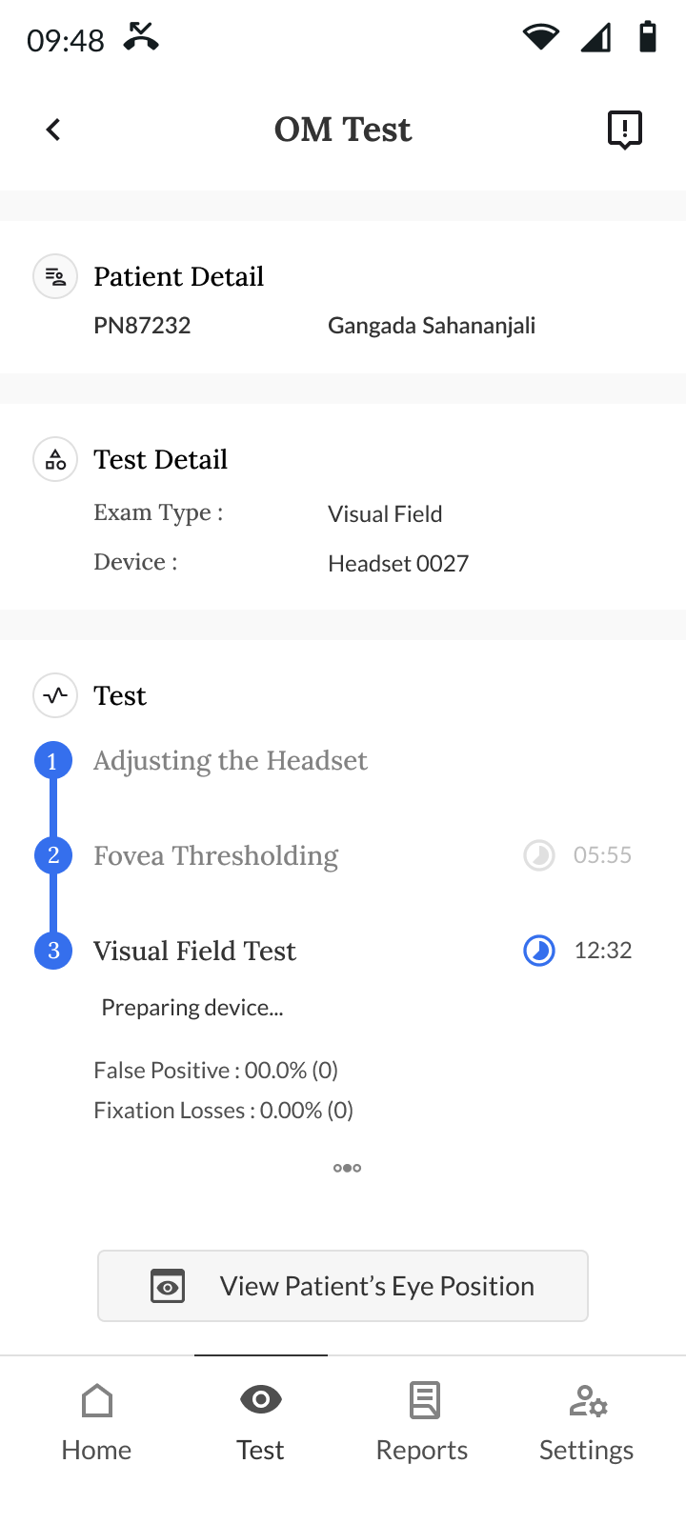

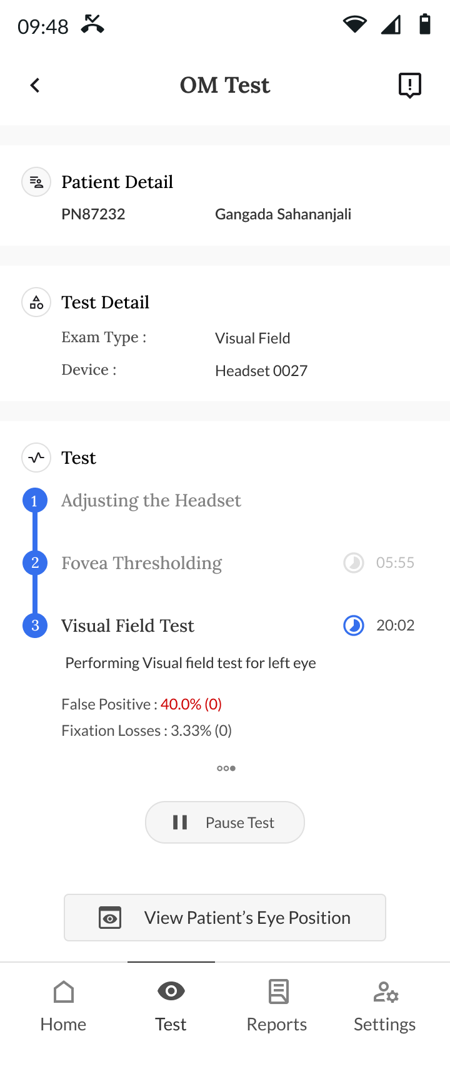 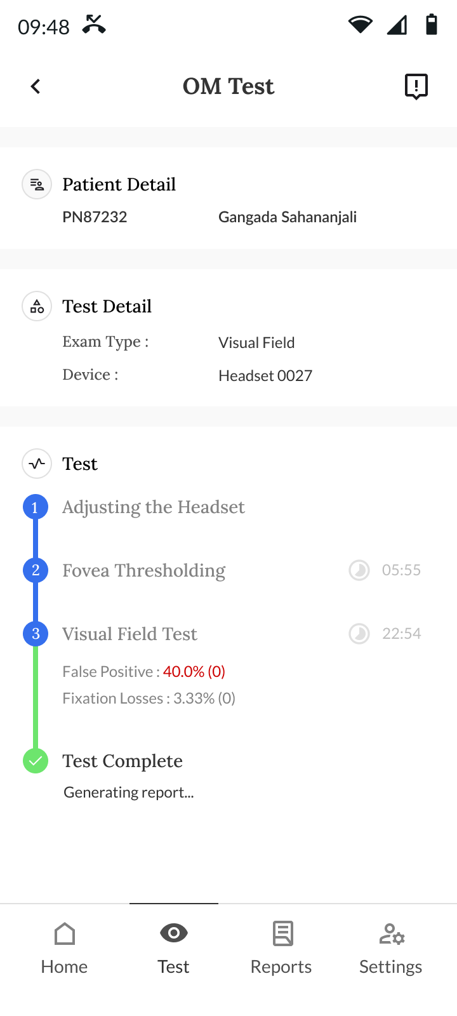

1. Test result screen featuring the OM report containing all test data points with the option to save/download the report after the test is completed.

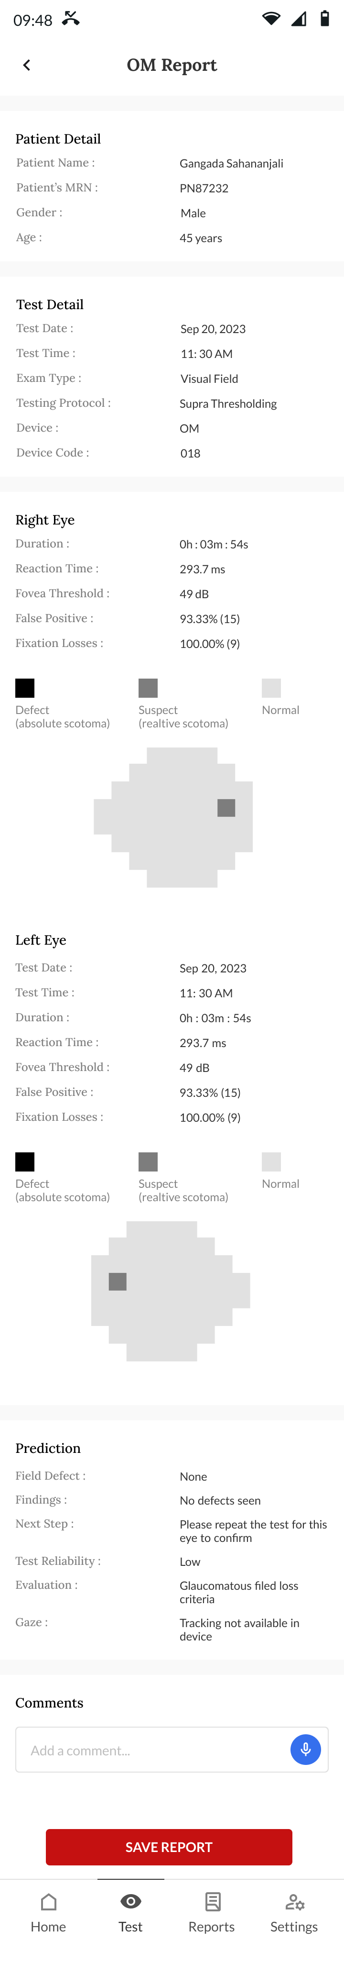

1. PupilX Test Setup: Selection list for various PupilX testing protocols, light intensity slider selector element, number of test cycles slider selector element, text input fields for light on/off duration, and a text input field for Device code.

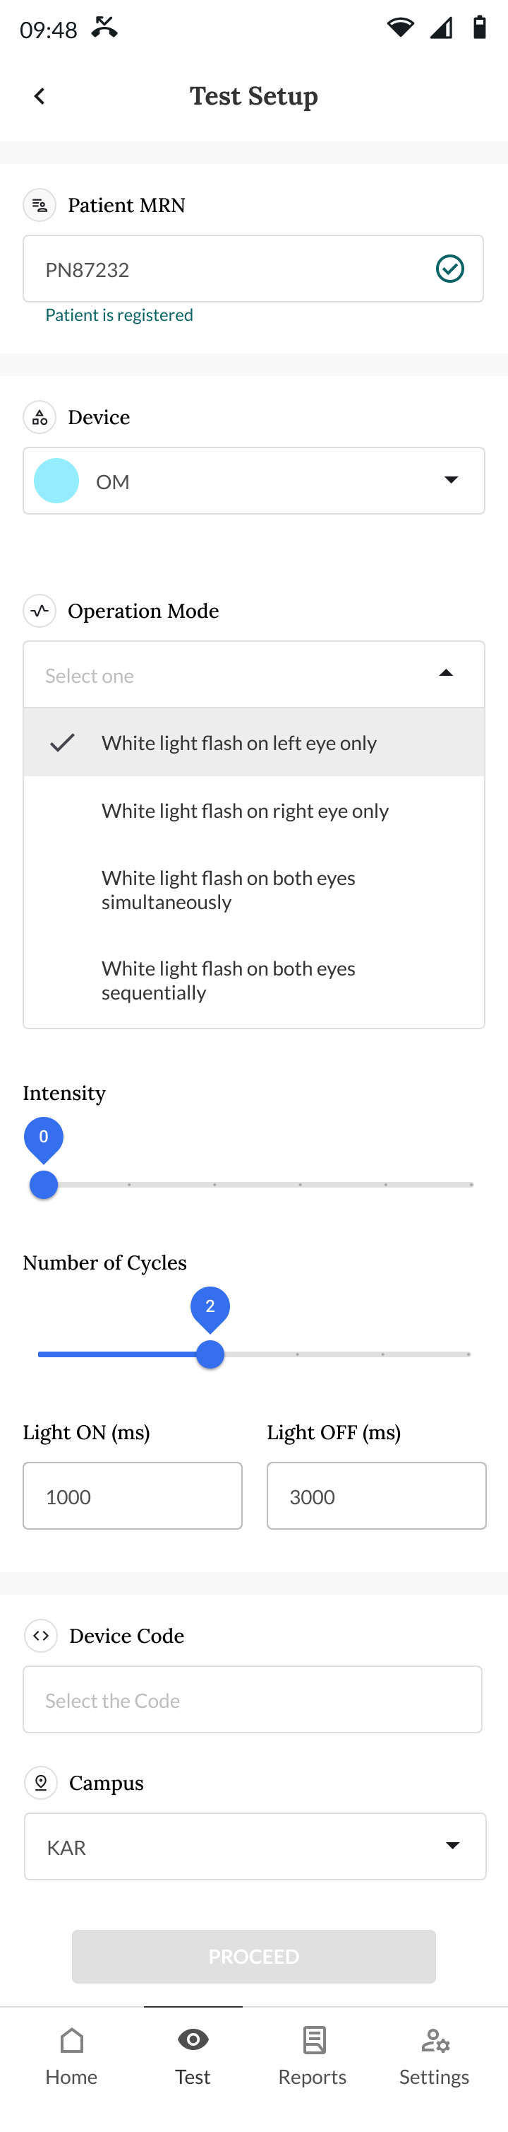

1. PupilX Test:
2. Pre-test start screen displaying selected patient details, chosen PupilX test protocol details, and instructions for headset adjustment.

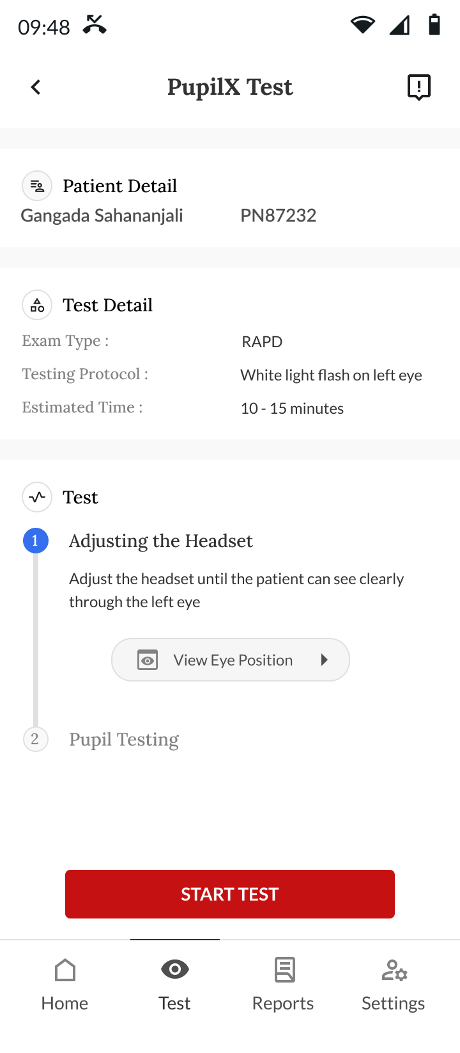

1. Screens providing instructions and validations for various stages of the PupilX test.

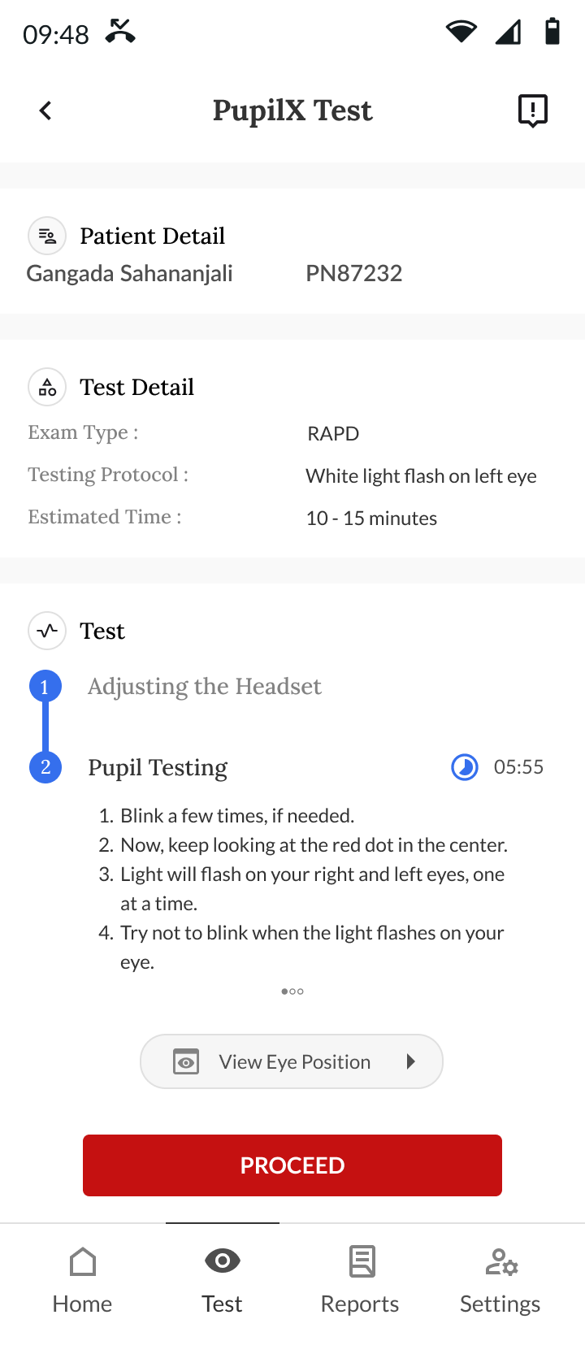 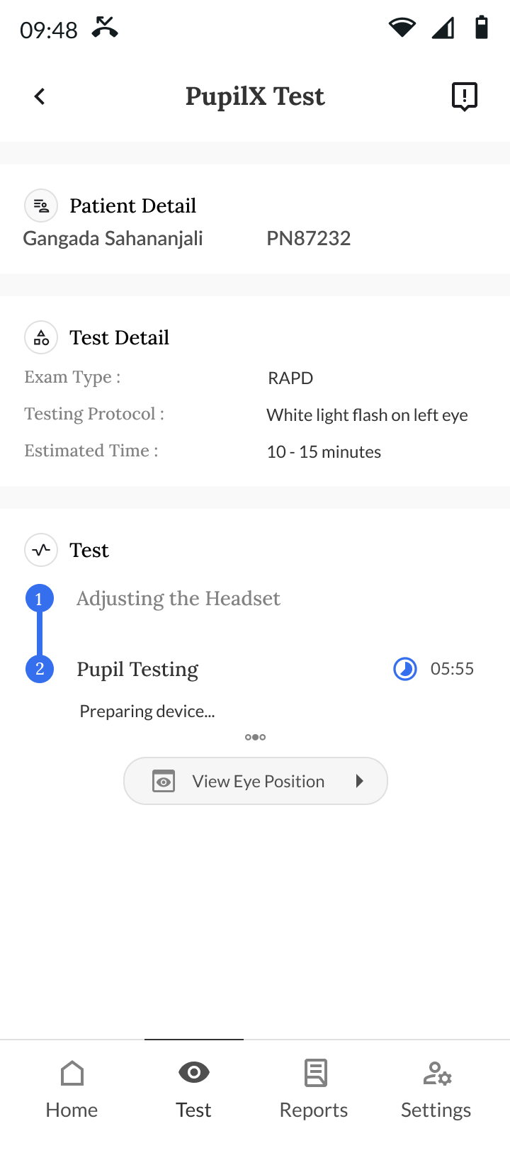 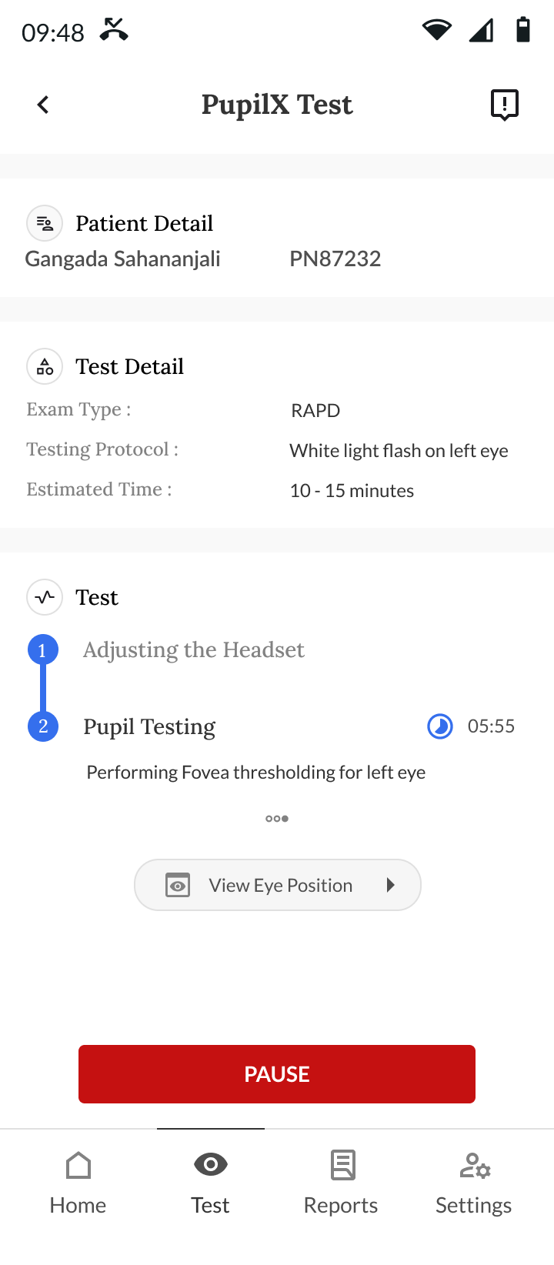

1. Test result screen featuring the PupilX report containing all test data points with the option to save/download the report after the test is completed.

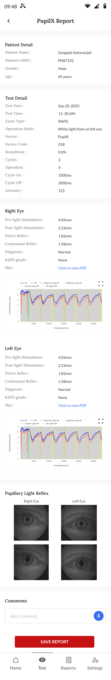

1. Common UI functions for OM and PupilX tests flow:
2. Pop-up window for viewing the live eye position of the patient during the test.

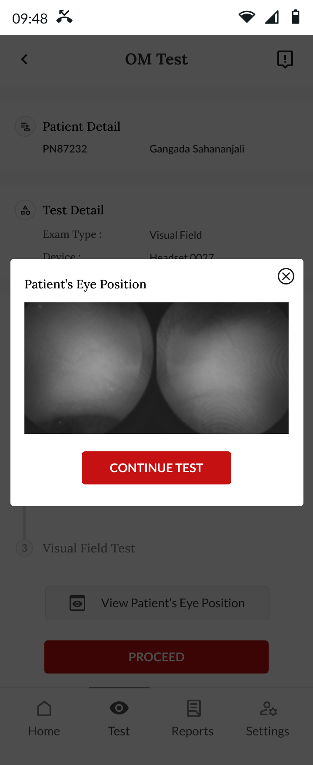

1. App notification displaying the real-time status of the ongoing OM or PupilX test.

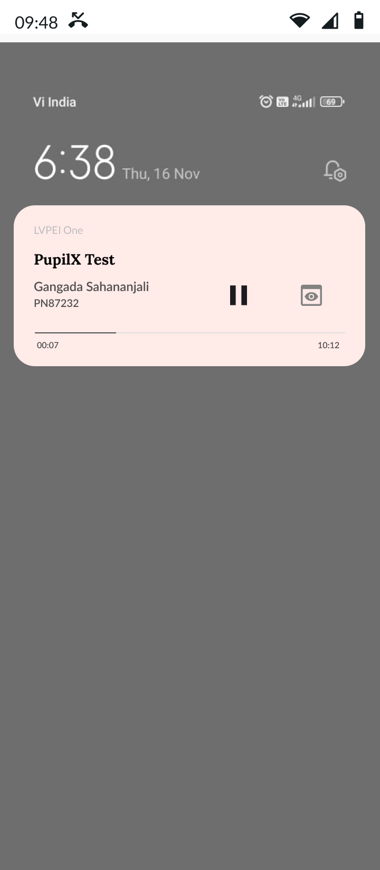

1. Confirmation pop-up window for aborting the ongoing test function.

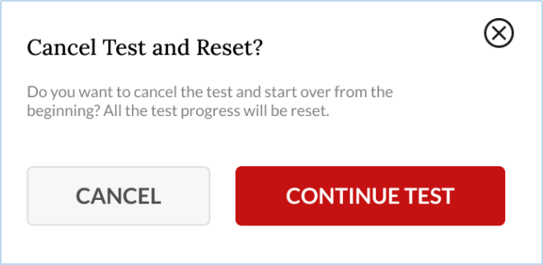

1. Adding comments to test reports through either text input or audio input.

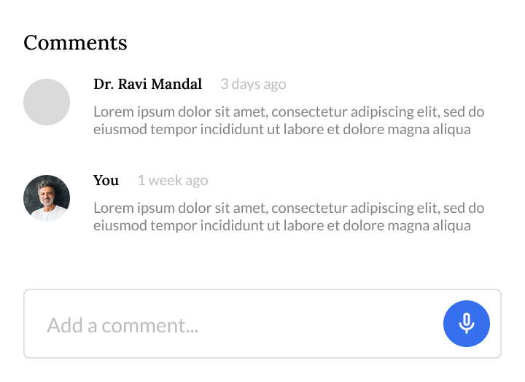

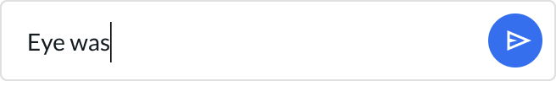

1. Reports Tab Module: The latest test reports are displayed by default when navigating to the reports tab. There is an option to search for reports by providing the patient MRN or Name in a text input field. A popup window allows for different search filter tabs, such as Doctor/Examiner list, Test name (OM/PupilX), Campus/Organization List, and Date range selector.

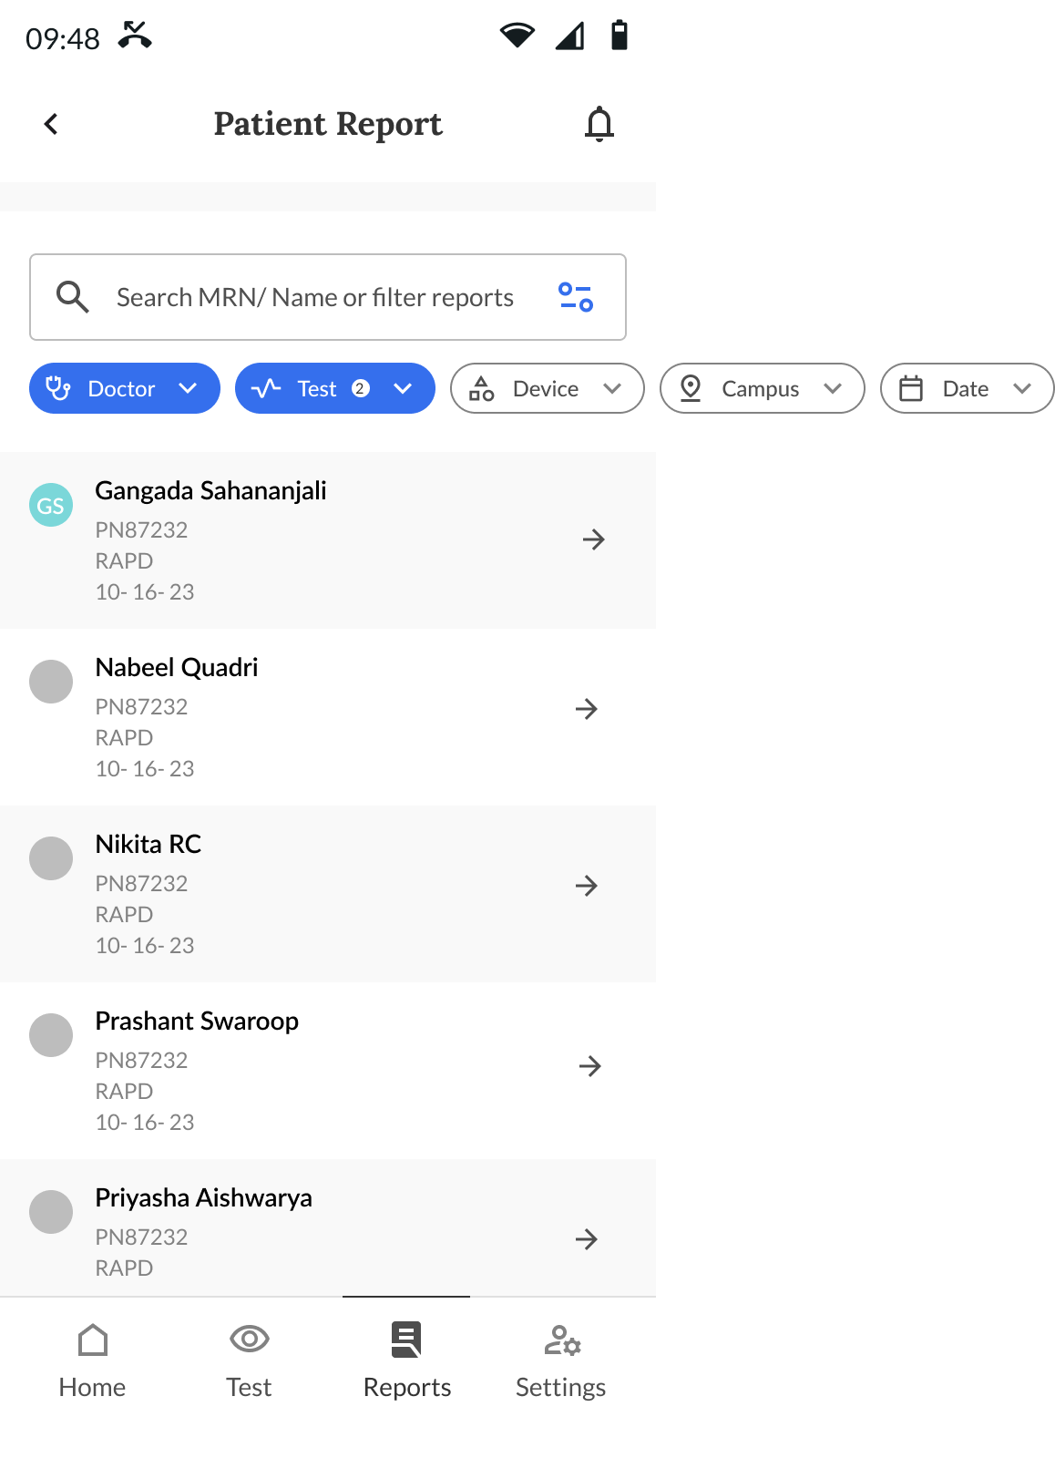

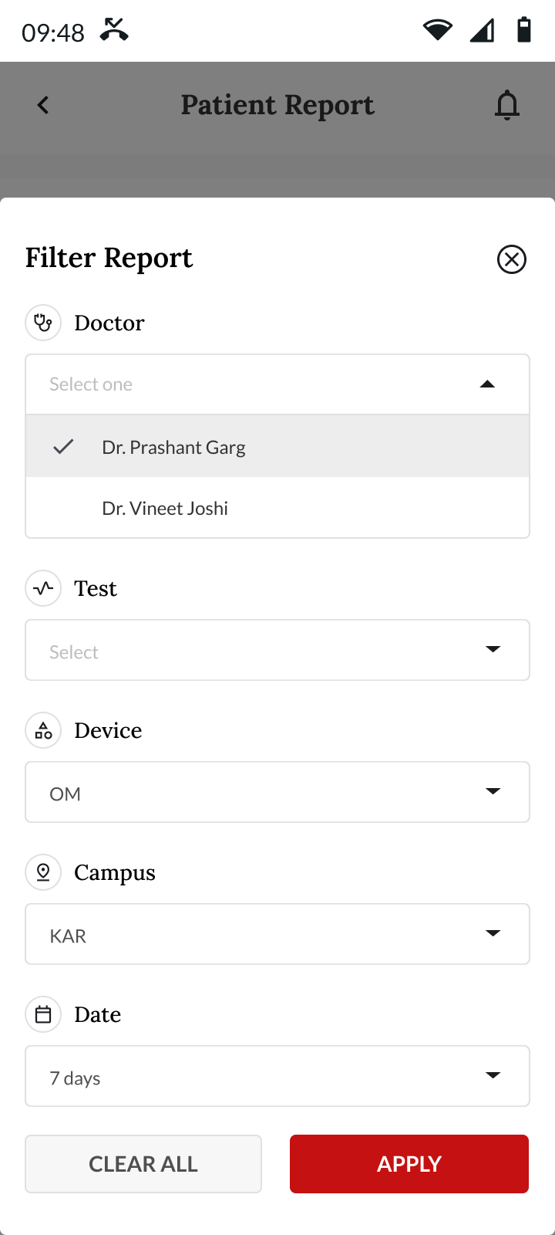

1. Settings Tab Module: Includes an app about page, user manual links, contact us option, report a problem page, the ability to edit logged-in user details from the profile page, and an app logout button.

